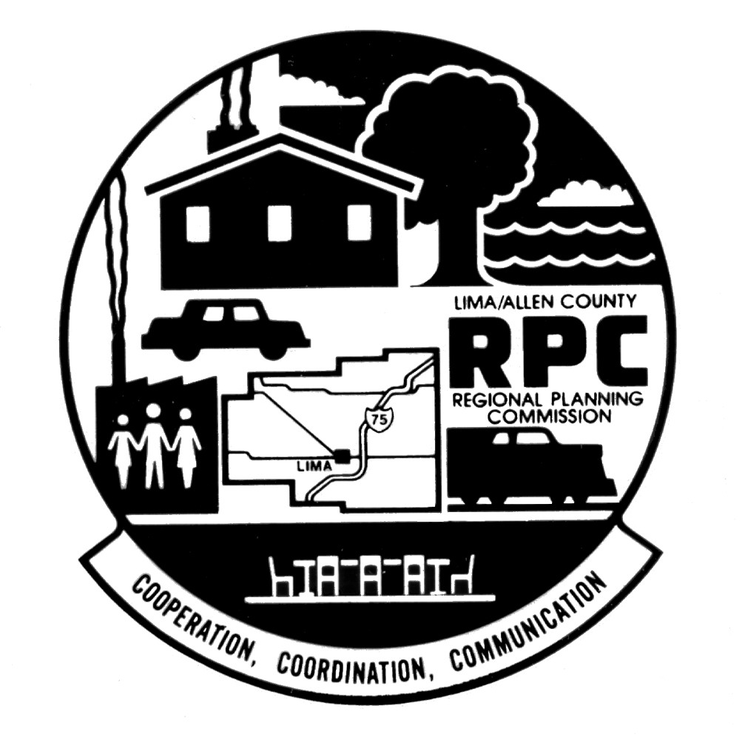
LIMA-ALLEN COUNTY REGIONAL PLANNING COMMISSION
130 West North Street Lima, Ohio 45801-4311
Telephone: 419-228-1836 FAX: 419-228-3891 www.lacrpc.com
COOPERATION, COORDINATION, COMMUNICATION
Teresa Adams
President

Richard Schroeder
President-Elect

John W. MacDonell
Treasurer

W. Dan Reiff
Secretary

Thomas M. Mazur
Executive Director
RECYCLED PAPER
March 9, 2015

«Title» «First_Name» «Last_Name»
«Affiliation»
«Address»
«PO_Box»
«City», «State» «Zip»

Dear «Title»«Last_Name» :

The Lima-Allen County Regional Planning Commission (LACRPC) is requesting public review and comment on the Draft FY 2016–2019 Transportation Improvement Program (TIP). An Open House is scheduled for Tuesday, March 31, 2015, between 2:00 and 6:00 p.m. at the offices of the LACRPC at 130 W. North Street, Lima, OH 45801.

Accommodations are available for those with special-needs. If transit services are needed, the offices of the LACRPC are on the Lima-Allen County Regional Transit Authority (LACRTA) fixed route system or paratransit service can be scheduled by calling the ACRTA at 419-222-2RTA (419-222-2782).

The Draft FY 2016–2019 TIP is available at the Lima-Allen County Regional Planning Commission web page at http://www.lacrpc.com/media/95080/DRAFT%20FY%202014-2017%20TIP--COMPLETE.pdf and is available for public comment. If you have questions regarding the FY 2016-2019 TIP, open house, or have a request to accommodate special-needs, please call the Commission office at 419-228-1836 or email esmith@lacrpc.com.

Respectfully,

Thomas M. Mazur
Executive Director

